|  |
| --- |
|  |
| An in-depth case study analysis of the Road and Maritime NSW |
|  |

|  |
| --- |
| SE 20232784 Jieyan LIANG |

catalogue

Introduction 1

ultimate goal 1

Potential solutions 1

The importance of improving business services 1

Blockchain: 1

Financial Technology (Fintech) : 2

Cloud Computing: 2

Big Data: 2

Data Mining: 2

Information system Modeling: 2

What will be changed by implementing the chosen information technology in the current situation 3

System changes: 3

Business model changes: 3

Value proposition changes: 3

Employee training and organizational changes: 3

organizational chart 5

The details of stakeholder management communication 7

1. Data Security and Privacy: 7

2. Staff training: 7

3. Business process adjustment: 7

4. Partner adaptation: 7

5. User experience optimization: 7

Summary and suggestion 8

Challenge: 8

Advantages: 8

comparison sheet 9

Reference 9

# Introduction

The primary objective of the case study is to investigate the significant consequences of contemporary decision-making, particularly with the aid of information systems. A comprehensive analysis of Roads and Maritime NSW (RMS) seeks to demonstrate the influence of information systems technology and management on actual business situations.

# ultimate goal

The purpose of this study is to create a thorough examination of Roads and Maritime NSW (RMS). The purpose of this report is to provide a comprehensive analysis of information systems and a well-crafted communication strategy for enhancing current business systems. The primary objective of the study is to advance the progress of existing business systems, enhance their effectiveness, and construct a more robust structure for managing stakeholders. The purpose of this study is to create a thorough examination of Roads and Maritime NSW (RMS). The purpose of this report is to provide a comprehensive analysis of information systems and a well-crafted communication strategy for enhancing current business systems. The primary objective of the study is to advance the progress of existing business systems, enhance their effectiveness, and construct a more robust structure for managing stakeholders. The purpose of this study is to create a thorough examination of Roads and Maritime NSW (RMS). The purpose of this report is to provide a comprehensive analysis of information systems and a well-crafted communication strategy for enhancing current business systems. The primary objective of the study is to advance the progress of existing business systems, enhance their effectiveness, and construct a more robust structure for managing stakeholders.

# Potential solutions

A variety of cutting-edge information technologies, such as blockchain, fintech, cloud computing, big data, data mining, information systems modeling, and information systems project management, can be chosen and utilized to create potential solutions. We are conducting an in-depth investigation into the possible uses of these technologies in order to offer creative and practical solutions to improve current operational systems for Roads and Maritime NSW (RMS). The objective of these solutions is to enhance systems, business models, value propositions, employee training, and organizational charts, while also motivating organizations to function more effectively within an information systems setting.

# The importance of improving business services

## Blockchain:

Blockchain technology has the potential to enhance data security and transparency within the information systems of Roads and Maritime New South Wales (RMS). It safeguards against data manipulation and guarantees the dependability of traffic and waterway administration. (El-Gazzar, R et.al 2020) Furthermore, blockchain can streamline the database synchronization procedure and diminish the possibility of data incongruity.

## Financial Technology (Fintech) :

Fintech can help improve customer registration and payment systems and make things more efficient.( Shi, W et.al 2022 ) Fintech can make the payment process for transportation services more efficient for RMS, resulting in a quicker and more reliable payment experience while cutting down on transaction expenses.

## Cloud Computing:

Utilizing cloud computing can enable RMS to more effectively control and store extensive amounts of traffic and waterway information. By utilizing cloud services, RMS can attain enhanced scalability and adaptability to cater to the increasing demands of users. Furthermore, cloud computing can offer sophisticated data analysis and visualization capabilities.

## Big Data:

The utilization of big data technology is essential for the examination and manipulation of the immense volumes of traffic and waterway data that RMS gathers. It can pinpoint traffic congestion, enhance road safety, and furnish robust backing for future infrastructure development.

## Data Mining:

By utilizing data mining techniques, RMS can uncover concealed patterns and trends within data. RMS can gain a deeper comprehension of public requirements and offer more intelligent and effective transportation services by studying user conduct and traffic flow.

## Information system Modeling:

The utilization of information system modeling aids in elucidating the disparities in business functionality between the RMS website and the Service NSW mobile application. A detailed information system model can help us understand the relationship between different systems and provide clear guidance for database synchronization and data analysis.

# What will be changed by implementing the chosen information technology in the current situation

## System changes:

The introduction of blockchain technology will improve the security and data integrity of the system. (Komala, M et al. 2023) Blockchain technology ensures secure and impermeable data storage through distributed ledger systems, enables secure data sharing to improve interoperability, and enhances the trust of the entire system through data encryption to prevent the risk of data tampering. (Singh, Y et al. 2023.)

Cloud computing will bring changes to the system architecture, achieving better scalability and elasticity. (Angiuoli, S. V et al. 2011.) This will help address growing user demand while improving system stability and performance.

Big data and data mining technology will enable the system to better analyze and utilize the large amount of accumulated data. This will change the way data is processed, enabling smarter decision making.

## Business model changes:

The implementation of fintech could revolutionize the way transportation services are paid, making it more efficient and convenient. Possible solutions may involve the implementation of novel payment methods, the provision of preferential schemes, or the enhancement of the entire payment system.

The utilization of big data and data mining techniques may result in more individualized and tailored transportation services. By studying user habits, RMS can gain insight into the requirements of the public and tailor services to satisfy the requirements of various users.

## Value proposition changes:

The implementation of cutting-edge technologies will enhance the standard and productivity of services. The new value proposition for RMS will encompass enhanced data processing security, intelligent transportation planning, and streamlined payment methods.

Enhanced data analysis and visualization services can facilitate governments and the general public in gaining a deeper comprehension of the condition of transportation and waterways, consequently enhancing the transparency and reliability of public services.

## Employee training and organizational changes:

Employees must be equipped with the necessary skills to adjust to novel systems and workflows when introducing new technology. Gaining knowledge of the latest data analysis techniques, comprehending the mechanics of blockchain technology, and other related topics could be part of this.

Organizational frameworks may need to be adapted to suit the implementation of new technologies. In order to guarantee the successful implementation and functioning of the new technology, it may be necessary to bring in new roles, such as data analysts and blockchain specialists and so on.

# organizational chart

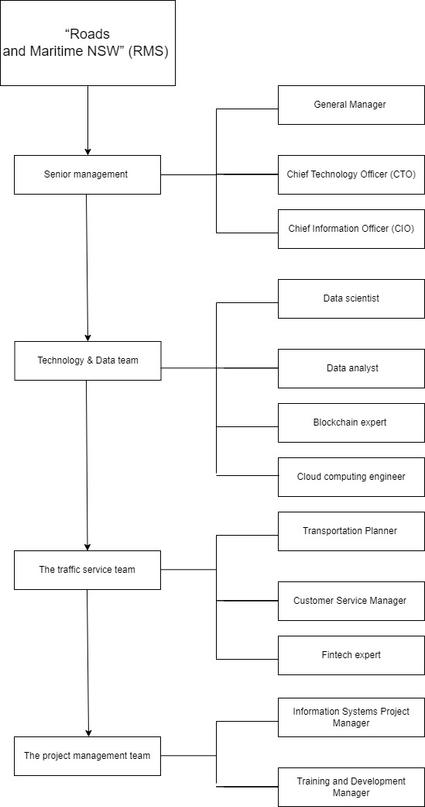

# The details of stakeholder management communication

Communication Plan: Changes and challenges in information technology implementation

## 1. Data Security and Privacy:

The implementation of blockchain technology will bolster the data security of our system, yet it may also give rise to some apprehensions regarding data privacy.

In response, we will enhance our safeguarding of data security and privacy while formulating explicit policies to guarantee adherence.

## 2. Staff training:

The implementation of novel technologies may necessitate personnel instruction to adjust to novel systems and procedures.

We will offer an extensive training program to guarantee that all personnel are proficient in utilizing modern technologies and achieving success in transformation.

## 3. Business process adjustment:

The implementation of big data and data mining technologies may necessitate us to reassess and modify certain business operations.

We will offer an extensive training program to guarantee that all personnel are proficient in utilizing modern technologies and achieving success in transformation.

## 4. Partner adaptation:

Our partners may need to adjust to novel methods of data exchange and processing due to the emergence of new technologies. In response, we will establish strong lines of communication with our partners to exchange change plans and offer assistance for a seamless transition.

## 5. User experience optimization:

The implementation of fintech could potentially revolutionize the way users pay, necessitating them to adjust to novel payment methods.

We will ensure that the new payment system is user-friendly by offering explicit instructions and assistance.

We recognize that transitioning may be challenging and uncomfortable, yet we are confident that these changes will result in more efficient, secure, and intelligent services. We will keep in contact with you to address your worries and guarantee that we collaborate towards a prosperous future. I am grateful for your backing and comprehension.

# Summary and suggestion

## Challenge:

The incorporation of these cutting-edge technologies necessitates thorough system modifications and incorporation, which can result in greater intricacy in the execution procedure. In order to guarantee a successful implementation, it is essential to have a well-structured project management plan and a proficient technical team.

Staff training and adaptation:

The implementation of novel technologies may necessitate employees to undergo training in order to acclimate to novel workflows and systems. Implement a thorough training program and keep in touch with staff to help them adjust.

Data privacy and security issues:

The utilization of blockchain and big data may give rise to apprehensions regarding the confidentiality and protection of data. Implement explicit privacy regulations and safety protocols to foster confidence among the public and stakeholders.

## Advantages:

Blockchain technology can be utilized to bolster the safety of data, thereby thwarting any attempts to tamper with it or gain unauthorized access.

- Enhance the trustworthiness of the entire system and decrease the likelihood of data breaches and malicious assaults.

The utilization of financial technology can streamline the payment procedure and enhance the effectiveness of services.

- Maximizing user experience, cutting down on transaction expenses, and boosting customer contentment are some of the benefits.

Cloud computing enhances the resilience and adaptability of systems to cater to the increasing demands of users.

- Enhance the system's scalability to guarantee optimal performance and accessibility.

Enhanced assistance for making wiser choices.

Organizations can leverage the power of big data and data mining technologies to gain a deeper understanding of and make the most of vast amounts of data.

Benefits: Offer enhanced decision-making assistance, enhance traffic and infrastructure planning, and address other facets of the impact.

# comparison sheet

reference: <https://cloud.tencent.com/developer/article/1359951>

|  |  |  |
| --- | --- | --- |
| **aspect** | **inspiration** | **limitation** |
| **blockchain technology** | Improve data security against tampering and unauthorized access. (Pelekoudas-Oikonomou, F et.al 2022) | Implementation and maintenance costs are high, requiring the support of professional technical teams. |
| **financial technology** | Improve payment efficiency, reduce transaction costs, and optimize user experience. | Users need to adapt to the new payment method, which may cause users to not adapt. |
| **cloud computing** | Improve system scalability and flexibility to meet growing demands. | You need to invest in cloud infrastructure and ensure data privacy and security. |
| **big data** | Provide smarter decision support to uncover hidden patterns and trends. | Data privacy and compliance issues require careful management and protection of user information. Data privacy and compliance issues require careful management and protection of user information. |
| **data mining** | Extract valuable information from data to optimize business processes | Large amounts of data need to be processed and may face processing power and storage issues. |
| **information system modeling** | Help clarify system functions and relationships, guide database synchronization and data analysis. | It requires an investment of time and resources and may cause discomfort and resistance from employees. |
| **information systems project management** | Effectively monitor and manage the change process to ensure that the project is on schedule. | Precise project planning is required and may present change management challenges. |

# Reference

Angiuoli, S. V., Matalka, M., Gussman, A., Galens, K., Vangala, M., Riley, D. R., Arze, C., White, J. R., White, O., & Fricke, W. F. (2011). CloVR: a virtual machine for automated and portable sequence analysis from the desktop using cloud computing. BMC bioinformatics, 12, 356. <https://doi.org/10.1186/1471-2105-12-356>

El-Gazzar, R., & Stendal, K. (2020). Blockchain in Health Care: Hope or Hype?. Journal of medical Internet research, 22(7), e17199. <https://doi.org/10.2196/17199>

Komala, M. G., Ong, S. G., Qadri, M. U., Elshafie, L. M., Pollock, C. A., & Saad, S. (2023). Investigating the Regulatory Process, Safety, Efficacy and Product Transparency for Nutraceuticals in the USA, Europe and Australia. Foods (Basel, Switzerland), 12(2), 427. <https://doi.org/10.3390/foods12020427>

Singh, Y., Jabbar, M. A., Kumar Shandilya, S., Vovk, O., & Hnatiuk, Y. (2023). Exploring applications of blockchain in healthcare: road map and future directions. Frontiers in public health, 11, 1229386. <https://doi.org/10.3389/fpubh.2023.1229386>

Shi, W., & Huang, Q. (2022). The Blockchain Technology Applied in the Development of Real Economy in Jiangsu under Deep Learning. *Computational intelligence and neuroscience*, *2022*, 3088043. https://doi.org/10.1155/2022/3088043

Pelekoudas-Oikonomou, F., Zachos, G., Papaioannou, M., de Ree, M., Ribeiro, J. C., Mantas, G., & Rodriguez, J. (2022). Blockchain-Based Security Mechanisms for IoMT Edge Networks in IoMT-Based Healthcare Monitoring Systems. Sensors (Basel, Switzerland), 22(7), 2449. <https://doi.org/10.3390/s22072449>